Matthew Clem
Professor Satterfield
IT 230
19 February 2026

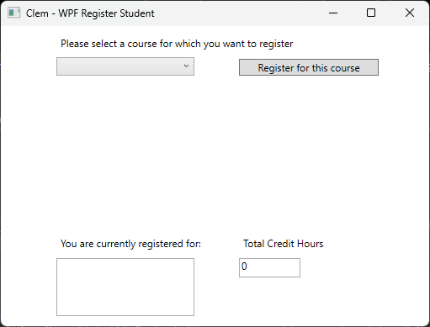
1. Provide a screenshot of the output that resulted from running your program successfully in Visual Studio.

Screenshot 1-Application Running

This screenshot shows the application running successfully with the user interface loaded and my last name displayed at the top of the window.

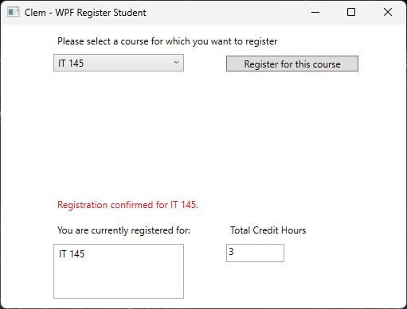

Screenshot 2 - Regostering for a Course
This screenshot shows the user selecting a course from the dropdown menu and registering for the course. The selected course appears in the registered courses list, and the total credit hours get updated.

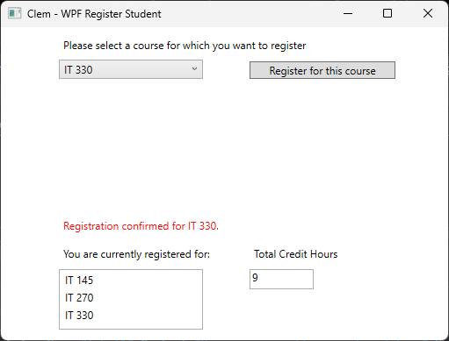

Screenshot 3 - Multiple Courses being registered.
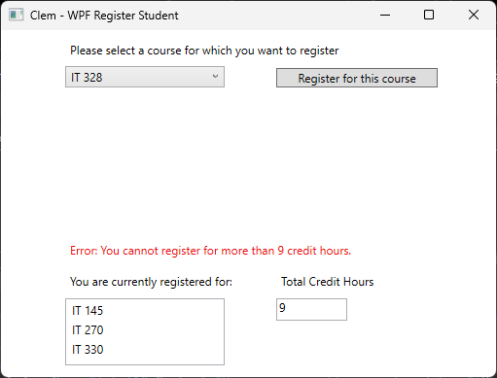
This screenshot shows multiple courses registered successfully and displays the updated total credit hours.

Screenshot 4 - Credit limit hit
This screenshot shows the program displaying an error message when attempting to register for more than nine credit hours.
2. Copy and paste the source code text you wrote for this assignment from the *.cs file into the space below.
MainWindow.xaml.cs:
using System;
using System.Collections.Generic;
using System.Windows;

namespace WPFRegisterStudent
{
/// <summary>
/// Interaction logic for MainWindow.xaml
/// </summary>
public partial class MainWindow : Window
{
Course choice;

// Credit hour rules
private const int CreditHoursPerCourse = 3;
private const int MaxCreditHours = 9;

// Track registrations
private int totalCreditHours = 0;
private List<Course> registeredCourses = new List<Course>();

public MainWindow()
{
InitializeComponent();
}

private void Window_Loaded(object sender, RoutedEventArgs e)
{
Course course1 = new Course("IT 145");
Course course2 = new Course("IT 200");
Course course3 = new Course("IT 201");
Course course4 = new Course("IT 270");
Course course5 = new Course("IT 315");
Course course6 = new Course("IT 328");
Course course7 = new Course("IT 330");

this.comboBox.Items.Add(course1);
this.comboBox.Items.Add(course2);
this.comboBox.Items.Add(course3);
this.comboBox.Items.Add(course4);
this.comboBox.Items.Add(course5);
this.comboBox.Items.Add(course6);
this.comboBox.Items.Add(course7);

// Reset UI
registeredCourses.Clear();
listBox.Items.Clear();
totalCreditHours = 0;
textBox.Text = "0";
label3.Content = "";
}

private void button_Click(object sender, RoutedEventArgs e)
{
// Get selected course
choice = (Course)(this.comboBox.SelectedItem);

// Validate selection
if (choice == null)
{
label3.Content = "Error: Please select a course.";
return;
}

// Business rule: no duplicate registrations
foreach (Course c in registeredCourses)
{
if (c.ToString() == choice.ToString())
{
label3.Content = "Error: You are already registered for " + choice.ToString() + ".";
return;
}
}

// Business rule: max 9 credit hours (3 courses)
if (totalCreditHours + CreditHoursPerCourse > MaxCreditHours)
{
label3.Content = "Error: You cannot register for more than 9 credit hours.";
return;
}

// Register the course
registeredCourses.Add(choice);
listBox.Items.Add(choice);

// Update total credits
totalCreditHours += CreditHoursPerCourse;
textBox.Text = totalCreditHours.ToString();

// Confirmation message
label3.Content = "Registration confirmed for " + choice.ToString() + ".";
}
}
}

